DSCI 784 - Project Report
Introduction
Amazon, as mentioned in the proposal, receives a substantial number of reviews from customers, granting them the opportunity to improve customer experience by discovering important information from those reviews such as opinions and concerns. However, analyzing these large unstructured data can be time-consuming and difficult for companies. Therefore, to help the store with the analysis, this project aims to apply topic modeling using the LDA algorithm on Amazon’s musical instrument review data.
Objective purpose
The purpose of this project is to do topic modeling on the reviewText variable of Amazon’s musical instruments review data. This technique can allow Amazon to understand the different topics that the customers discussed in the reviews. Once topics are identified, the store can discover fake reviews that contain incentive-related keywords or those having keywords that violate the community guidelines. If present, these can be removed to enhance customer experience.
Text acquisition
The dataset is a CSV file with 9 variables, namely reviewerID, asin, reviewer Name, helpful, reviewText, overall, summary, unixReviewTime, reviewTime. This data has been retrieved from Kaggle which can be accessed at: Amazon
Text preparation and transformation
To have reliable results, it is crucial to prepare and transform the text. Before training the model, the text was inspected for missing values. There were 7 missing rows which I removed because the LDA algorithm cannot function well with missing text. Then the reviews were tokenized using the ‘tokenize’ function. This function ensures that the tokens do not have commas, periods, and symbols, allowing the model to focus on relevant input like texts and numbers. Also, it standardizes the texts by converting all the tokens into lowercase, which prevents the model from treating the same word as separate tokens due to their case difference. It should be noted that the LDA algorithm needs tokens as input instead of sentences. Also, I removed stopwords from the tokens as these are a list of repeated words that do not contribute value. For transformation, I applied lemmatization because after training the initial model and analyzing one of its wordclouds, there were certain words like ‘guitar’ and ‘strings’ that had heavy weights, but their singular/plural forms also had a slightly heavy weight as depicted below. Hence, I applied lemmatization to only focus on the base forms of the words which can help make the topics more targeted. Finally, I removed numbers because, as shown below, one of the topic’s word clouds had general numbers that were heavily weighted. These do not add value. For my initial model, the following were my parameters: Chunk size = 10, Train Iterations = 400, Topics = 5.
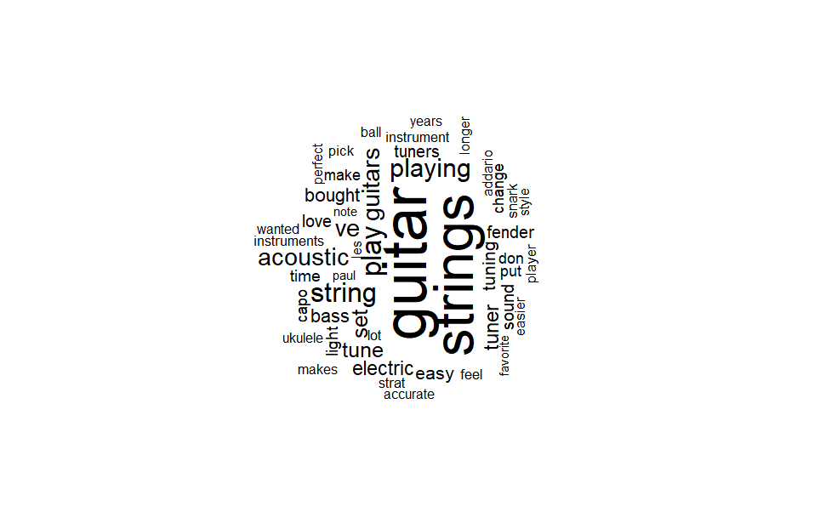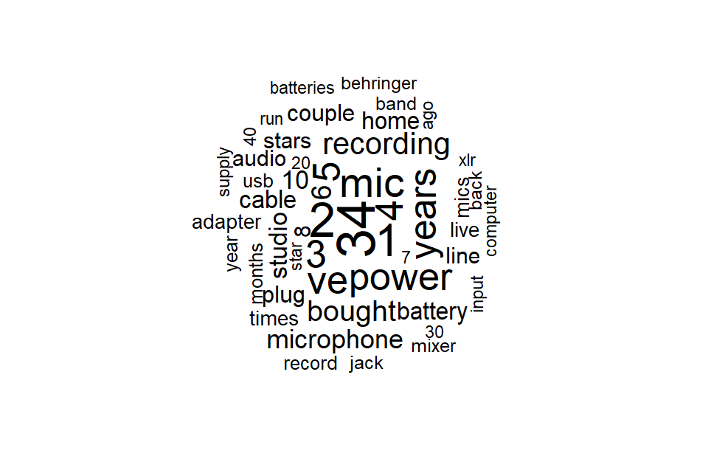

Results and visualizations

For this project, I used 10 as the chunk size because the reviews are not long. Before building the final model, various iterations and topic (k) values were attempted to prevent overfitting and show non-overlapping topics. After the initial model, I built another model using the same parameters, but I varied the iterations between 100 to 400 with 100 increments. The word clouds showed better clusters when using 300 as opposed to 200 iterations. However, there were no improvements when I used 400. Hence, I selected 300 to avoid overfitting. The following shows the results:
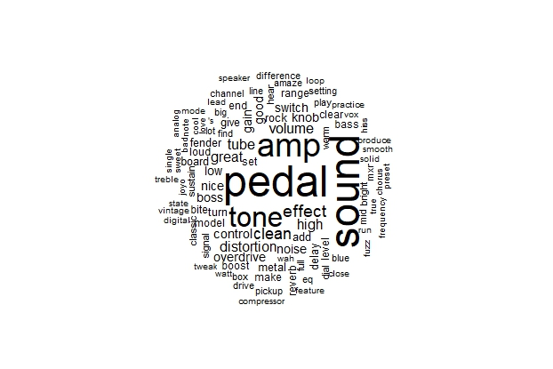
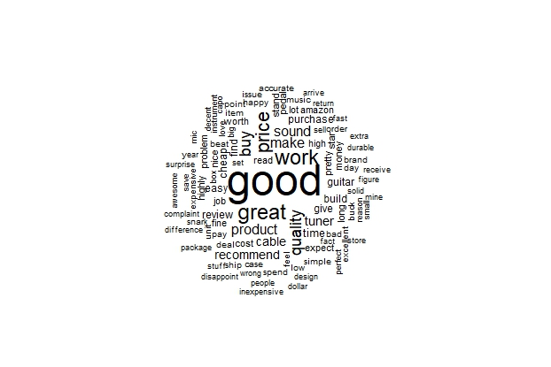

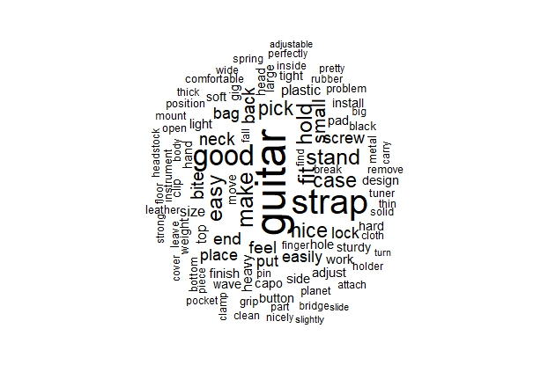
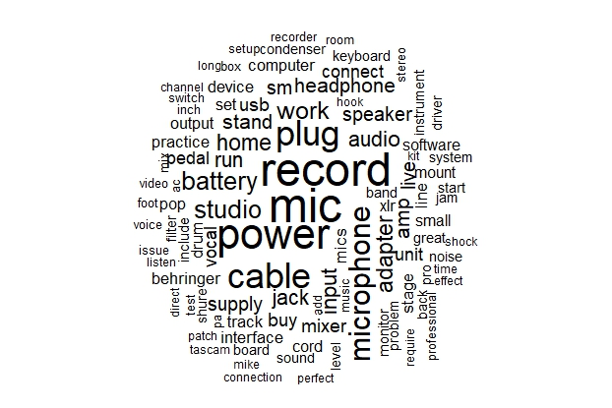

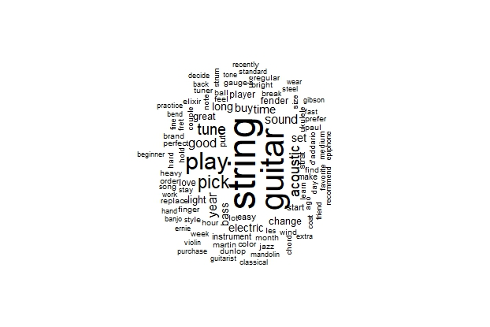

In the above word clouds, we see that the topics were related to the following: Instrument’s quality, Instrument’s sound, Guitar’s accessories, Instrument’s recording feature, and Guitar’s performance. This result was surprising because two of them were related to guitars. Since the data is on musical instrument reviews, I expected the topics of the reviews to be diverse. This shows that guitars are important topics and customers discussed two different aspects of them. As part of my iterations, I varied the topics from 3 to 7. When the topics were above 3, the word clouds showed slightly overlapping topics which were on different aspects of guitars. However, since my goal is to show distinct topics, I decided to reduce the number of topics. After reducing the topic to 3 and using 300 iterations, the results showed non-overlapping topics as shown below. These topics were related to the following: Instrument’s quality, Instrument’s sound, and Guitars. Furthermore, regarding the quality topic, the word ‘good’ is heavily weighted, meaning that customers, in general, have a positive sentiment toward these instruments. This was my final model because it provided optimal results.
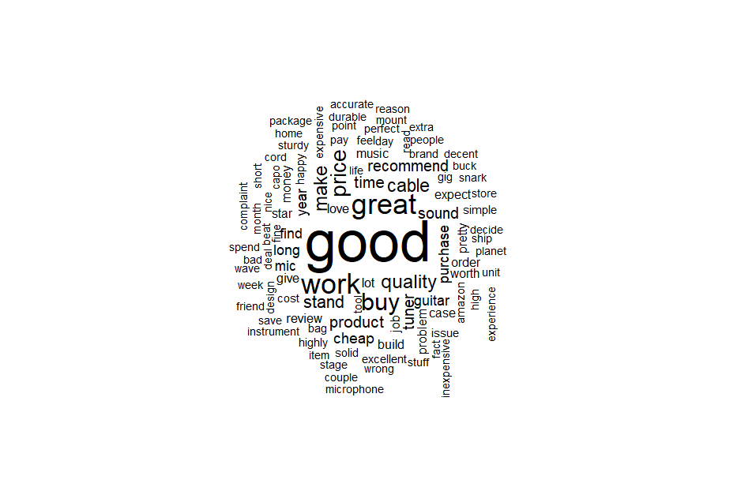
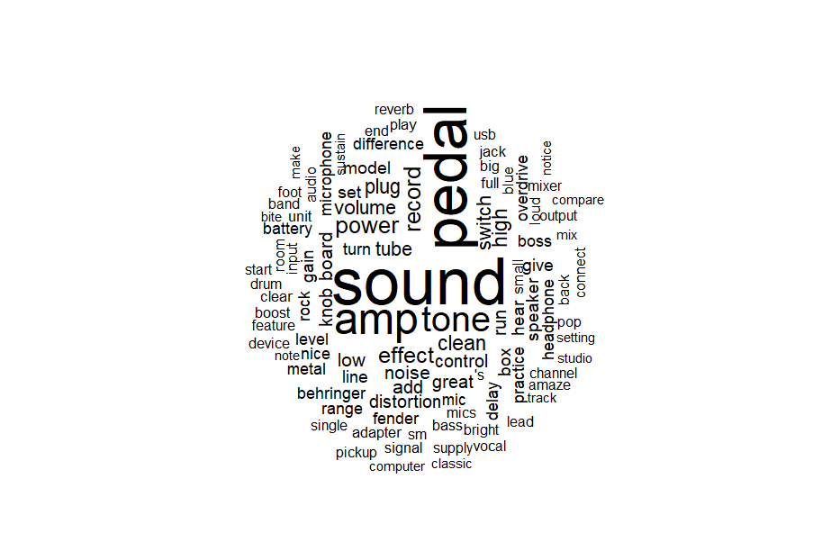

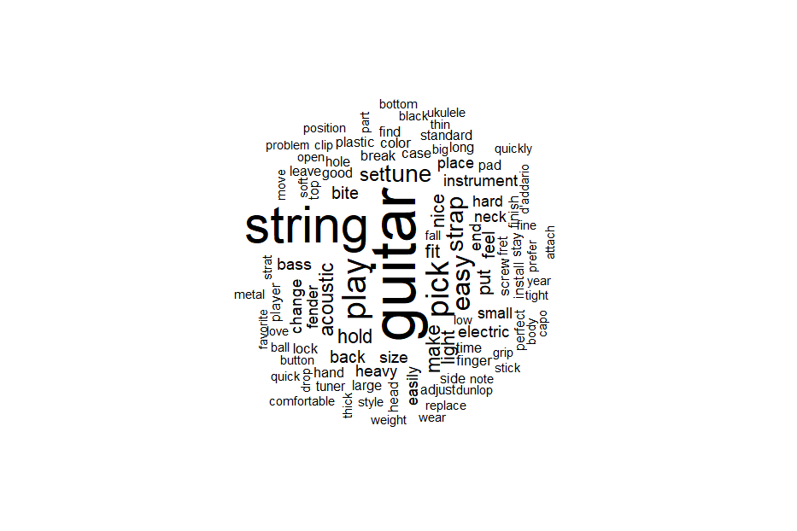
Additionally, I created a bar plot to visualize the frequency distribution of top words in each topic. Results show that the word frequencies follow Zipf’s law as depicted below.

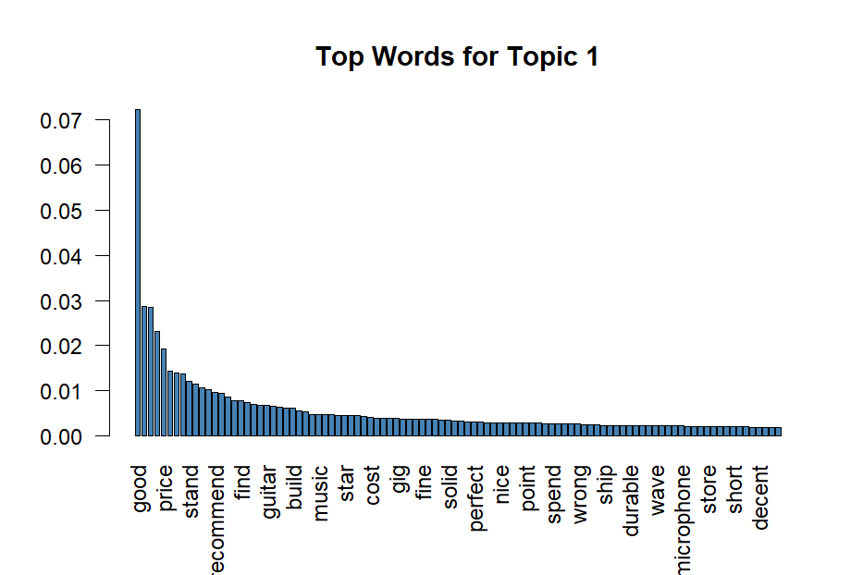

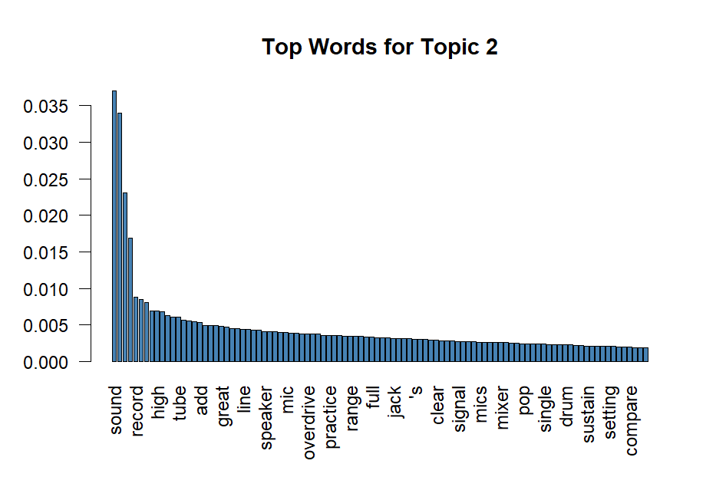

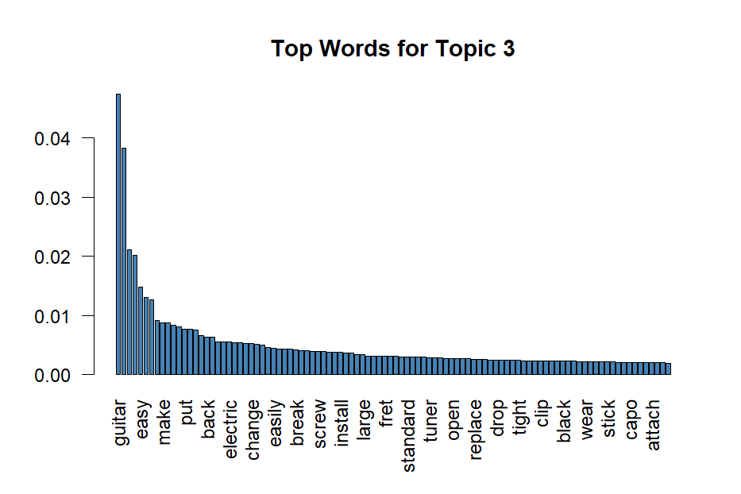

Next, I created a lexical dispersion plot for guitar and music as shown below. The plot shows that guitar is a highly common word that has been mentioned in many reviews. While music is a common word as well, it is not as frequently mentioned.
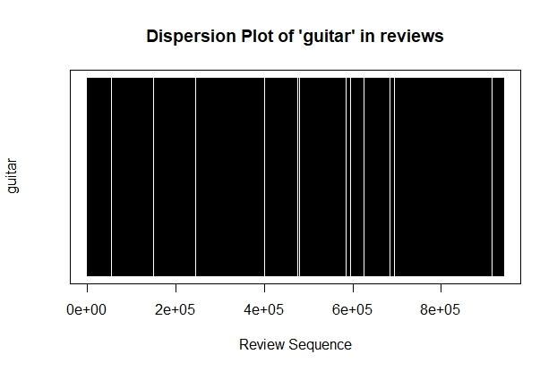

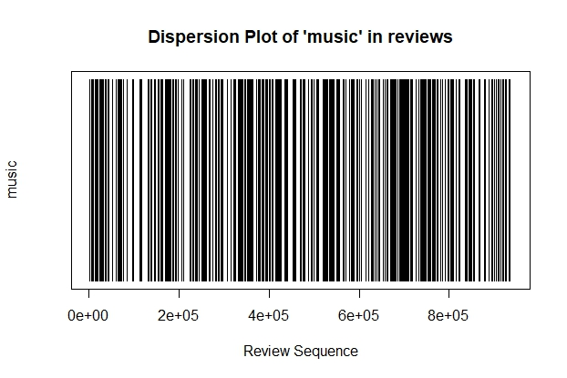

Finally, I examined the presence of keywords that violate community guidelines. I chose the words “abuse” and “attack” as my keywords. What was surprising is that some of the reviews did contain those words as shown below. This is unexpected since the dataset is about the customers’ reviews on musical instruments. Hence, this necessitates ‘keyword in context’ analysis to learn about the context of those keywords before deciding to remove those reviews.

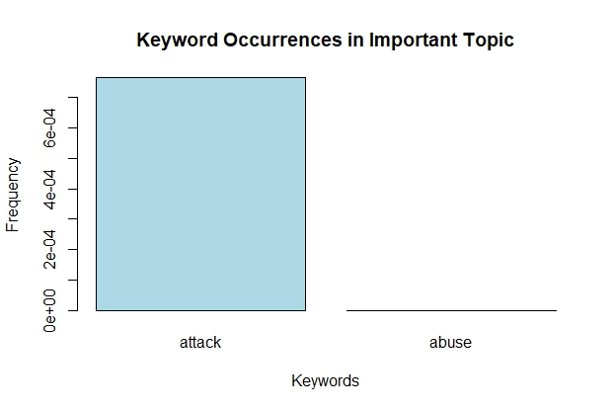
Conclusion

In conclusion, with the help of topic modeling, I discovered that guitar is the most common topic in the reviews because there were separate word clouds for it when the number of topics was above 3. Additionally, although the goal of this project was to show the general themes of those reviews, the analysis provided an insight into customers’ sentiment which was positive. Finally, the reviews contained community-violating keywords, which require further analysis before their removal.

